How to prepare and submit an article for publication in Quaderni di Ricerca in Didattica/Mathematics (QRDM)

Author(s) name(s)
Author(s) affiliation(s)

E-mail: correspondent's email address
Abstract. The abstract text should be formatted using 10 point Times (or Times Roman, or Times New Roman) and indented by about 25 mm from the left margin. Leave about 10 mm space after the abstract before you begin the main text of your article. The abstract follows the addresses.
- File preparation and submission
These guidelines give some suggestions on how to prepare and format your manuscript using Microsoft Word. Please note that we can accept only Word format manuscripts. The final version of your contribution will be published online as a pdf file.

1.1 What you will need to supply
Each contribution should be saved as a separate file in three formats: doc/docx and rtf . All accompanying references, figure legends, and tables are to be included.
Give each individual file your own name (or an abbreviation), and the format suffix, e.g.

Miller3.doc or Miller3.rtf
Embed all figures and tables into the file.
In addition to the figures being embedded in the text (Word file) of your article, you are asked, where possible, to supply all figures as separate graphics files in any of the following
File formats:
EPS, PDF, WMF, TIFF, GIF, JPEG and BMP.
Please enclose a list of all the files with your submission.
Keep personal copies of the files.
2. The general QRDM policy
Quaderni di Ricerca in Didattica/Mathematics is a multi-lingual and multimedia journal, devoted to publication of papers, books and media works describing significant experiences in the field of Mathematics Education Teaching and Research.

3. Title, author list and abstract

3.1 The title
The first letter of the title should be capitalized with the rest in lower case. The title should be formatted using 18 point Times Bold, flush left and unjustified, and you should leave 30 mm of space above, and 12 mm below the title.

3.2 Author list
Include all authors in a single list. The style for the names is: initials (with full stops) or forenames and family name, each author’s name separated with a comma, precede the final name with ‘and’. Chinese-style names should be typed as the author wishes his/her name to appear in print.

3.3 Addresses and footnotes
The addresses of the authors’ affiliations follow the list of authors. If the authors are at different addresses, numbered superscripts should be used after each family name to indicate his/her address.
The numbered superscripts should not be inserted using Word’s footnote command because this will place the reference in the wrong place—at the bottom of the page (or end of the document) rather than next to the address. A footnote, linked to the author, should be used to indicate an alternate address or the author to whom correspondence should be addressed.

3.4 E-mail addresses
These may be added after the authors’ addresses.

3.5 The abstract
The abstract follows the addresses and should give readers concise information about the content of the article and indicate the main results obtained and conclusions drawn. It should be self-contained with no reference to figures, tables, equations or bibliographic references and should not normally exceed 300 words. The abstract should normally be restricted to a single paragraph.
Two versions of the abstract should be submitted. One of these versions has to be in English, the other in French.

4. Writing your text
You can use all the functions in Word, type styles such as bold or italics, the indexing function, and the footnote function.
Only use the return key at the end of a paragraph or after headings, displayed lists, and the like. Do not insert manual hyphenation and do not use formats such as framing, centring, or shading.

4.1 Typing
Use a single main font for the article text. We recommend 11 point Times New Roman (or Times Roman). For special characters, please use Symbol.

4.2 Length
The manuscript total length should not exceed 1800 words. If you need more space, please arrange it with the conference organisers.
4.3 Emphasis
Please set emphasized words or phrases in paper text as italics.
If you want to give special emphasis to text sentences, please reduce the character dimensions to 10 points and continue using italics.

4.4 Headings
A well-structured text and meaningful headings make it easier for the reader to get a general idea of the text.

4.5 Style, spacing and numbering
Table 1 shows our preferred format for section headings.

Table 1. Formatting sections, subsections and sub subsections.

 | Numbering | Font | Spacing
Section | 1., 2., 3., etc | 11 point Times bold | 1 line (12 points) space before a section  3 points of additional space after a section heading
Subsection | 2.1, 2.2, 2.3, etc | 11 point Times Italic | 1 line (12 points) space before a section  3 points of additional space after a section heading
4.6 Acknowledgments
If you wish to acknowledge assistance or encouragement from colleagues, special work by technical staff or financial support from organizations you should do so in an unnumbered ‘Acknowledgments’ section immediately following the last numbered section of the article.

4.7 Some style points
It will help readers if your article is written in a clear, consistent and concise manner. If you are not native speaker in the language you are writing your paper, please consider the possibility to have your manuscript reviewed by a native speaker before submitting it us.

4.8 Footnotes
Footnotes should be only be used when essential, and if required should be used only for brief notes.

5. Figures
Each figure should have a brief caption describing it and, if necessary, a key to interpret the various lines and symbols on the figure. Aim to keep the lettering on figures to a minimum and include as much detail as necessary in the captions.
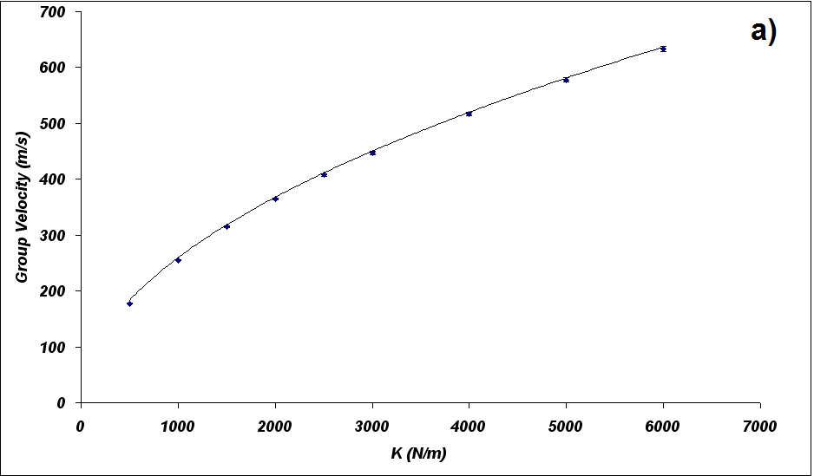
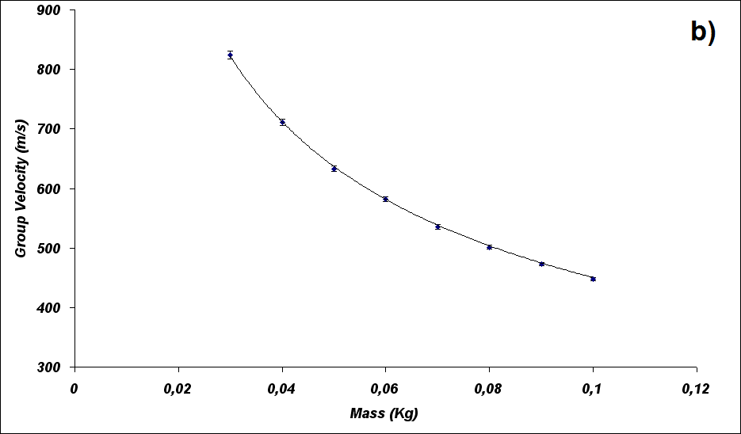
Figure 2. Group velocity as a function of K (a) and M (b)
5.1. Figure captions/numbering
Captions should be placed below (or next to) the figure and should finish with a full stop (period). Figures should be numbered sequentially—‘Figure 1’, ‘Figure 2’, and should be cited in the text as ‘figure 1’, ‘figure 2’.

5.2. Supplying figure files
Please note that all figures must be embedded within the text (Word document) of your article and supplied as separate figure files in any one of the acceptable file formats listed in section 1.1 (you can, of course, use any combination of the supported formats).

5.3. Text in figures
Do not put a title or caption detail in the figure file; any description should be placed in the figure caption.

5.4. Naming your graphics files
Please follow the file naming guidelines in section 1.1 and give each graphics file a name which easily identifies the content. For example: Figure1.eps, Figure2a.tif, Figure2b.tif rather than long descriptive names such as Beerslaw.jpg.

5.5. Colour illustrations
Use of colour in the online version of your article is free and you are strongly encouraged to make good use of colour where it will help readers of your article.

5.6. Positioning figures
Individual figures should normally be centred. It is also more convenient if figures are placed as close as possible, and ideally after, the point where they are first mentioned in the text.

5.7. Figures in parts
If a figure has parts these should be clearly labelled as (a), (b), (c) etc on the figure. Parts should not have separate captions, but the caption should describe the different parts.

6. Tables
An example of a table can be found in Section 4.5

6.1 Positioning tables
Tables should be centred unless they occupy the full width of the page.

6.2 Table captions/numbering
Captions should be placed at the top of the table and should finish with a full stop (period). Narrow captions should be centred, longer captions simply typed as a paragraph. Tables should be numbered sequentially: ‘Table 1’, ‘Table 2’, and should be cited in the text as ‘table 1’, ‘table 2’.

6.3 Rules in tables
Tables should have only horizontal rules and no vertical ones. Generally, only three rules should be used: one at the top of the table, one at the bottom, and one to separate the entries from the column headings.

7. Equations and mathematics
Mathematics should be prepared using Word’s built-in ‘Equation Editor’ or the full MathType product.
7.1 Fonts in Equation Editor (or MathType)
Make sure that your Equation Editor or MathType fonts, including sizes, are set up to match the text of your document.

Acknowledgements
If you want to acknowledge the work of someone or you want to recall the source of funding of the research that made possible your paper, this is the right place to do it.
Acknowledgements should be placed after conclusions but immediately before appendices (if any) or reference list. Please do not number the Acknowledgements headline.

References
References may be cited in the text in this way:
- Harvard system: author name/s and year of publication in parentheses:
one author: (Miller, 1991),
two authors: (Miller & Smith, 1994),
three authors or more: (Miller et al., 1995);

Entries in the list of References must be listed alphabetically. The rules for alphabetization are:
- first, all works by the author alone, ordered chronologically by year of publication,
- next, all works by the author with a co-author, ordered alphabetically by co-author,
- finally, all works by the author with several co-authors, ordered chronologically by year of publication.

Please do not number the References headline.
Some examples:

Paper in a Journal
Harris, M., Karper, E., Stacks, G., Hoffman, D., DeNiro, R., Cruz, P., et al. (2001). Writing labs and the Hollywood connection. Journal of Film Writing, 44(3), 213–245.

Book
Calfee, R. C., & Valencia, R. R. (1991). APA guide to preparing manuscripts for journal publication. Washington, DC: American Psychological Association.

Book chapter
O’Neil, J. M., & Egan, J. (1992). Men’s and women’s gender role journeys: Metaphor for healing, transition, and transformation. In B. R. Wainrib (Ed.), Gender issues across the life cycle (pp. 107–123). New York: Springer.

Online document
Abou-Allaban, Y., Dell, M. L., Greenberg, W., Lomax, J., Peteet, J., Torres, M., Cowell, V. (2006). Reliious/spiritual commitments and psychiatric practice. Resource document. American Psychiatric Association. http://www.psych.org/edu/other_res/lib_archives/archives/200604.pdf. Accessed 25 June 2007.

Web site
Grim web site. http://math.unipa.it/~grim/menu_quaderni.htm. Accessed 10/03/2010

