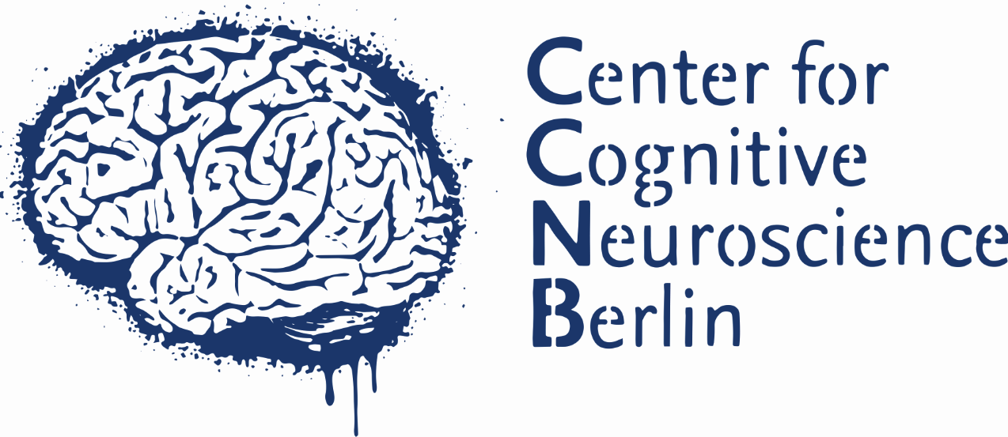
CCNB__________
V__________

MR questionnaire

Magnetic Resonance Imaging
Department of Education and Psychology
Freie Universität Berlin

Name, first name :.............................................. .................................................. .................

For your own safety, please read this questionnaire thoroughly and answer all questions honestly. If you are not sure or do not understand a question, please contact one of our employees. Please sign the questionnaire.

Important: due to the very strong magnet, no equipment or devices made of metal or that may contain metal, may be taken into the examination room. Store such items and devices (e.g., mobile phones, coins, pens, keys, hair clips, watches, jewellery, eyewear, belts, hearing aids, pagers) outside the scanner room!

Attention: the magnetic field is always on!
Enter the examination room only if requested by the staff!

Please answer:
1 | Are you a carrier of a pacemaker, defibrillator, hearing aid, drug pump (insulin?), neurostimulator, implant with magnetic valve (e.g., artificial anus)?  If so, which?………………………………………………………………………………… | Yes No
2 | Have you ever had head or heart surgery?  If so, why?………………………………………………………………………………… | Yes No
3 | Do you have metal parts or metal devices on or in your body (e.g., artificial limbs, electrodes, catheters, holder, radiation sources, acupuncture needles, piercings)?  If so, which? ………………………………………………….….…removable? Yes No | Yes No
4 | Do you have any implanted metal body parts or implants e.g., from a surgery (e.g., hip replacements, artificial joints, heart valves, vessel closures or expansions, surgical clips, bone screws or plates, spiral, shunts, catheters, electrodes, coils, radiation sources, shrapnel, bullets, stents)?  If so, which?................................................................................................................. | Yes No
5 | Do you wear magnetically fixed implants (e.g., dentures, glass eyes)? | Yes No
6 | Do you work privately or professionally with metal? | Yes No
7 | Do you wear dentures, bridges or braces?  If so, which?............................................................................. removable? Yes No | Yes No
8 | Do you suffer from a severe disease of the respiratory, cardiovascular or the movement system (e.g., asthma, heart failure, heart rhythm disturbances, paralysis)?  If so, which?................................................................................................................. | Yes No
9 | Do you suffer from diabetes or a seizure disorder (e.g., epilepsy)? | Yes No
10 | Are you disposed to claustrophobia, vertigo or panic attacks? | Yes No
11 | Do you have tattoos or permanent make-up? | Yes No
12 | Are you allergic to contrast media? | Yes No
13 | Do you suffer from other allergies?  If so, which?............................................................... | Yes No
14 | Are you currently on a regular medication?  If so, which?........................................................................................ | Yes No
15 | Have you taken drugs or alcohol in the last 24 hours? | Yes No
16 | Do you suffer from tinnitus? | Yes No
17 | Do you need glasses? | Yes No

Only women:
18 | Could you be pregnant? | Yes No
19 | Do you wear a copper coil? | Yes No

Birth Date:………………………. Height:………………. Weight:…………………

I understand this information and have answered all questions truthfully.

Date:……………………… Signature:…………………………………………

– wird vom Personal ausgefüllt –

Untersuchung unbedenklich

KEINE Untersuchung möglich

Bemerkungen:.........................................................................................................................................

Datum:........................................... Unterschrift:..............................................................................

